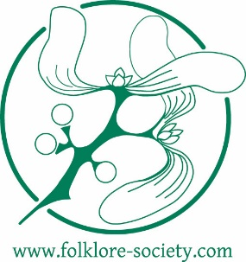
Working Life
Belief, Custom, Ritual, Narrative
A Folklore Society conference, Friday 27 to Sunday 29 April 2018 at the Museum of English Rural Life, University of Reading, 6 Redlands Road, Reading RG1 5EX
CALL FOR PAPERS
Submissions are invited for papers that explore a range of themes, customs, narratives, traditions and beliefs relating to the working life. Proposals of 100-150 words, for presentations of 20 minutes, should be emailed to thefolkloresociety@gmail.com and copied to enquiries@folklore-society.com. Deadline: 7 January 2018. Please include a brief biographical note, including contact details.
Themes for discussion might include, but are not limited to:
- Calendar festivals and working life
- Working life and the narrative tradition
- Work songs and occupational identities in ballads and popular poetry
- Special practices at work—rites of conclusion, taboo expressions
- Apprenticeship and initiation rituals, trade processions and myths of origin
- Traditional humour about trades and professions
- Informal rules of work, office jokes and sanctioned perks
- The use of custom, omens, mascots and other lore as a bargaining tool with employers
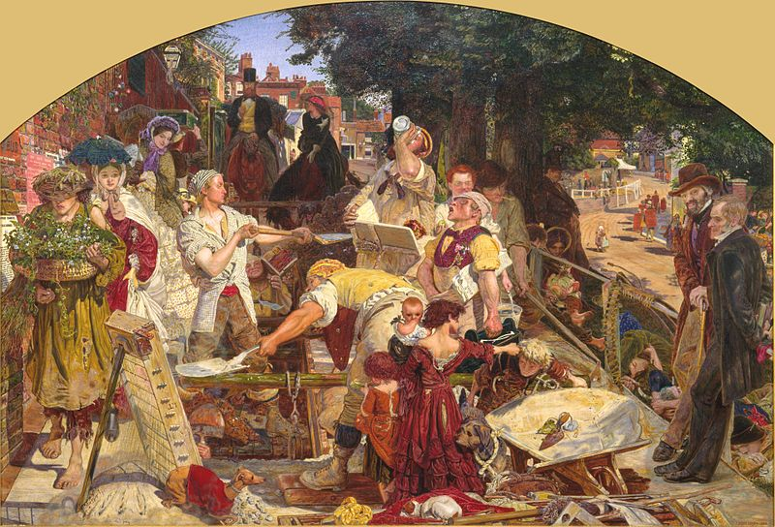
- Themes from work in folk art, murals and vernacular architecture

